**Advanced Networking**

**Dr. Abraham**

**Lab 5**

**For all assignments, please submit in one word document with all screen captures pasted on to it with comments for each screen capture.**

Due date: Check blackboard

**Install any version of Windows server. Create Domain Controller and join the domain. Create a domain for the server you installed. After that, join your windows workstation to that domain.**

**Explanation:** A Windows Server provides for TCP/IP suit, DHCP, DNS, Forest (one or more Active Directory domains) with Active Directory Domain Services (AD DS), and a user database. You will probably set up a **single domain model, consisting of a single forest and a single domain.** This domain is the forest root domain, and it contains all of the user and group accounts in the forest.

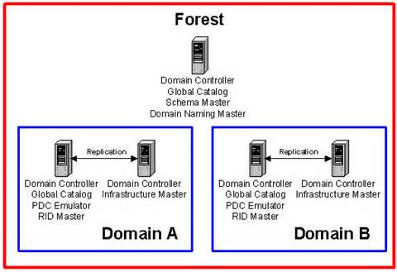

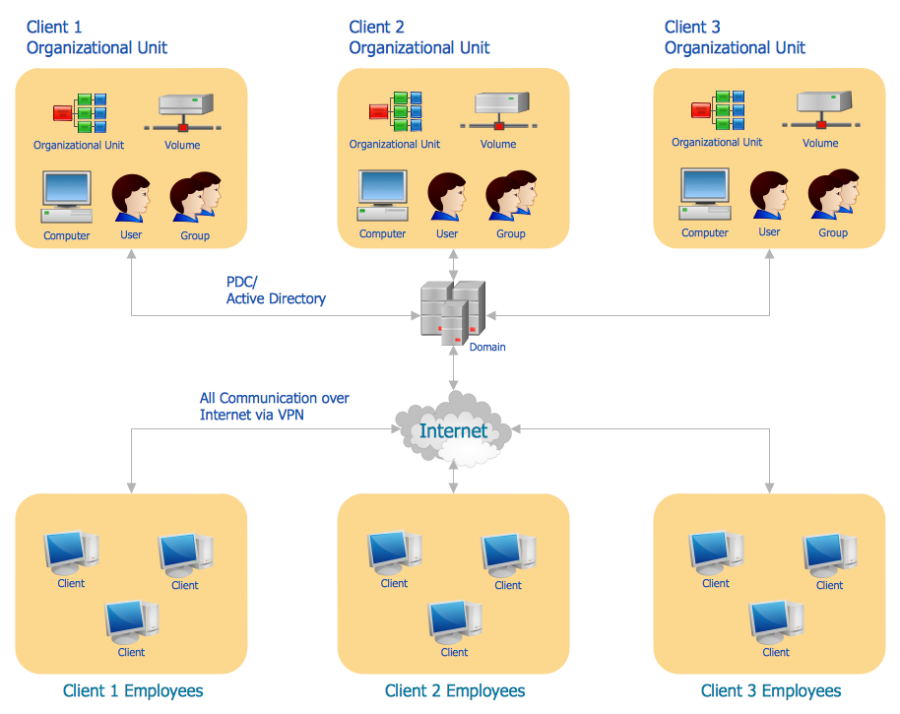

**Assignment:** Create a domain controller, DNS and DHCP for your virtual server and create a scope for your DHCP IP V4.

**Help:** You will have to set up a static IP before configuring your domain (DNS). Static IP can be set up by going to the control panel’s network and internet, network and sharing center and change your adapter settings. Right click on the adapter and choose properties, choose IP V4, and choose properties again. Here you can specify your IP address, Mask, default gateway and DNS settings. You may need to obtain some of this information from your current virtual machine configuration. Please capture screenshots as you are doing this exercise. Also capture a screenshot of installed services.